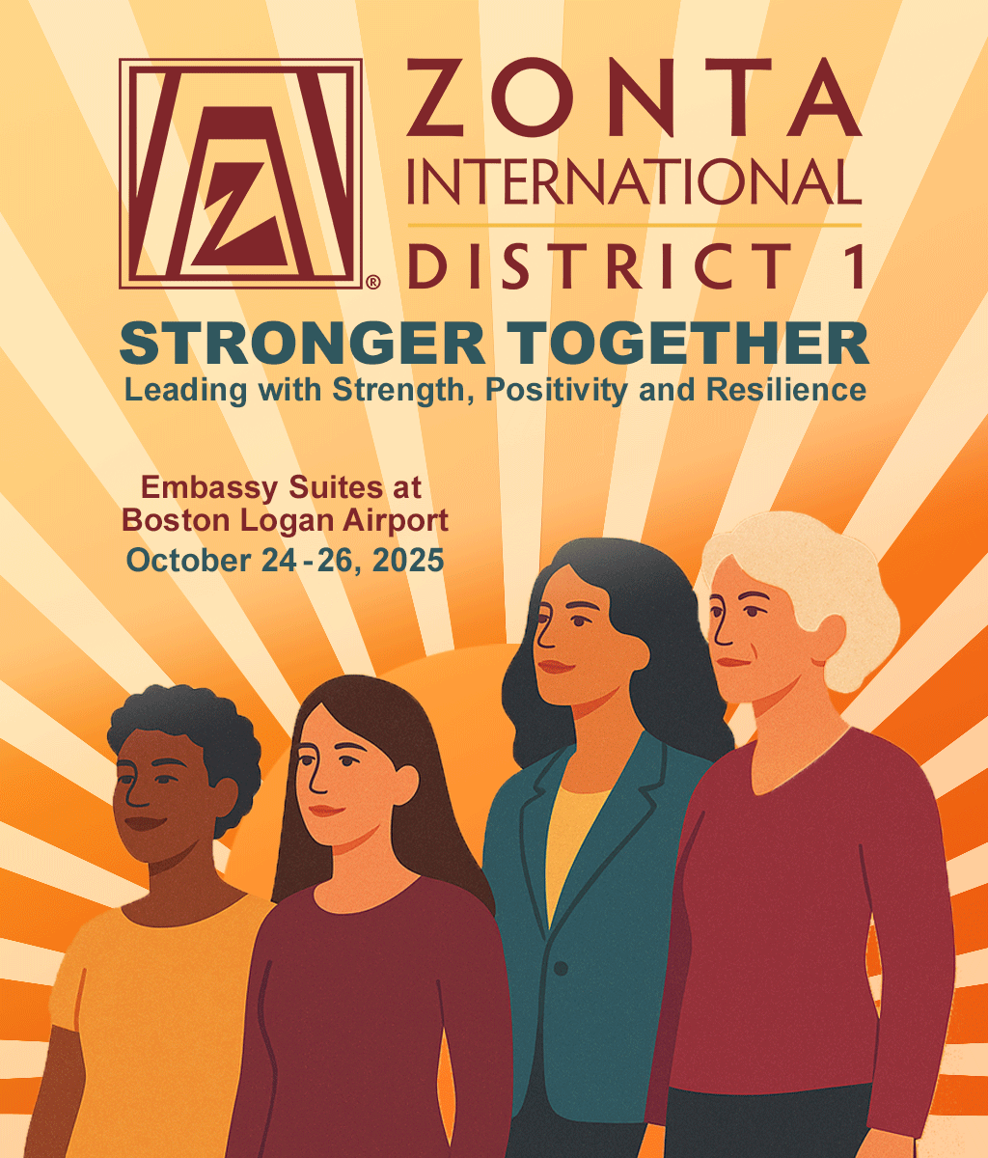
2025 CONFERENCE REGISTRATION
October 24 – 26 at Embassy Suites, Boston Logan Airport
Please complete the registration below or register online at zontadistrict1.org/fall-conference-2025

Name: Click or tap here to enter text. Email: Click or tap here to enter text. Phone: Click or tap here to enter text.
Zonta Club of:Click or tap here to enter text. Other Affiliation: Click or tap here to enter text.
Attending as (check all that apply):
Conference fees include
Friday night program
Saturday meetings, afternoon luncheon, evening banquet and entertainment
Sunday morning memorial and meeting
Beverages and snacks

We are securing Conference Sponsors to keep the cost affordable. See Event Sponsors.
☐1st Timer* ☐Guest
☐ Club Member ☐District Officer/Chair
☐ Past Director Governor
☐ Other - please indicate: Click or tap here to enter text.

Conference fees for US residents:
☐ US $99 Early Bird rate (before 7/1)
☐ US $125 (7/1-10/1)
* 1st timers receive $25 rebate in mail after conference
☐ US $150 (after 10/1)
Conference fees for CA residents:
☒ US $75
Guests: ☐ Saturday dinner US $75
Cancellation Policy (info@zontadistrict1.org)
Cancellations received before 9//15 will receive full refund.
Cancellations after 9/15 will receive 50% refund.
No refunds will be given for cancellations received after the start of the conference.
Payment can be made by credit card or check:
Use camera on QR code to access Square Account
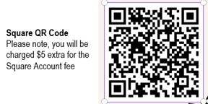
☐I paid US $ online Square Account

☐ I am enclosing a check made payable to
Zonta International District 1
Memo: District Conference.

Submit Registration
Print and complete this form. Mail it to:
Mary Knight (Zonta District 1 Secretary)
PO Box 1034, Belchertown MA 01007-1034

ARRANGE TRANSPORTATION AND BOOK YOUR ROOM at the Embassy Suites by Hilton Boston at Logan Airport
We have a block of suites with a special rate reserved for Friday, October 24, through Sunday, October 26.
2 Room Suite $279/night includes 2 queen beds + sofa bed (3-6 people), two TVs, wet bar, desk and chair, Wi-Fi, free made-to-order breakfast, restaurant, pool, gym. Free shuttle to and from airport; $30/day parking.
Reservation link

